Activity 14 Firebase Cloud Messaging
Emmanuel Gohourou
November 9, 2026

1 Setup and payload
I set up Firebase before starting the app so messaging wouldnt run before Firebase was ready. I kept one screen and two local images to make the changes easier to check. The action has to be update_ui. The asset value picks default or promo from the image map. In T1, the promo value showed the green campus event image and the title changed to New promotion.

2 Lifecycle and evidence
The T1 screenshot shows onMessage while the app was open. T2 shows onMessageOpenedApp after tapping a notification while the app was in the background. T3 shows getInitialMessage after removing the app from recents and opening its notification. Its count restarted at 1. onBackgroundMessage does background work in a separate Android isolate. It cant directly change the widgets because it doesnt share the screen state. These tests checked the three receipt and opening paths.

3 Validation and next step
For T4, asset was changed to unknown. The app showed Message skipped and kept the previous title and green image. The count still went up because a message arrived. The before and after screenshots show this. The first background attempt arrived too early and used onMessage. Waiting until the home screen was active fixed the test. I would add a short message history so I could look back at earlier messages instead of only seeing the latest one.

Test setup
Device: InClass09_Test Android Studio emulator, sdk_gphone16k_arm64, Android 17. Notification permission: authorized.
Messages were sent to the current emulator token through the Firebase HTTP v1 API. The same valid payload was used for T1, T2, and T3.
{
"notification": {
"title": "New promotion",
"body": "Switch the screen to the promo asset"
},
"data": {"asset": "promo", "action": "update_ui"}
}
T4 change: asset=unknown. The title, body, and action stayed the same.

Test results
Test | Expected | Observed | Result | Evidence
T1 | onMessage; new title and promo image. | onMessage, count 1. New promotion and the green event image appeared. | Pass | T1
T2 | onMessageOpenedApp after a notification tap; promo title and image. | onMessageOpenedApp, count 3. The notification opened the promo screen. | Pass | T2
T3 | getInitialMessage after a notification cold start; count 1 and promo screen. | getInitialMessage, count 1. The notification started the app and showed the promo screen. | Pass | T3
T4 | onMessage; warning, higher count, previous title and image stay. | onMessage, count 2. Message skipped appeared. New promotion and the green image stayed. | Pass | T4
T2 was retried because the first attempt arrived while the app was still moving to the background. That extra foreground receipt is why the passing T2 count is 3.

Limits
Only this Android emulator was tested. A physical phone, iOS, and a separate data-only background message were not tested. The T1-T4 cases passed.

Repository
https://github.com/emmanuelori00/MADProjects/tree/inclass_act14/inclass_act14

T1 Foreground receipt
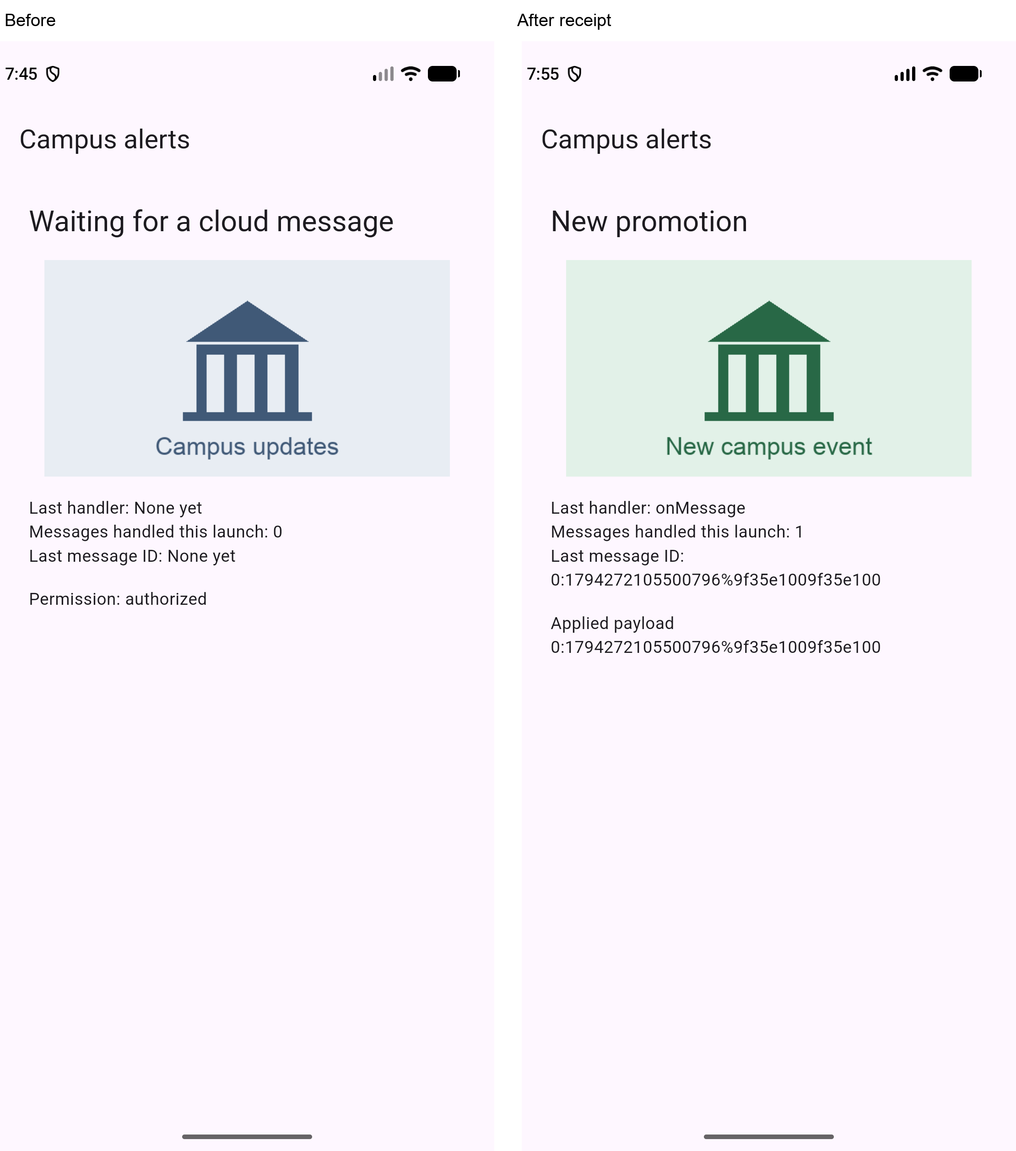

T2 Background notification tap
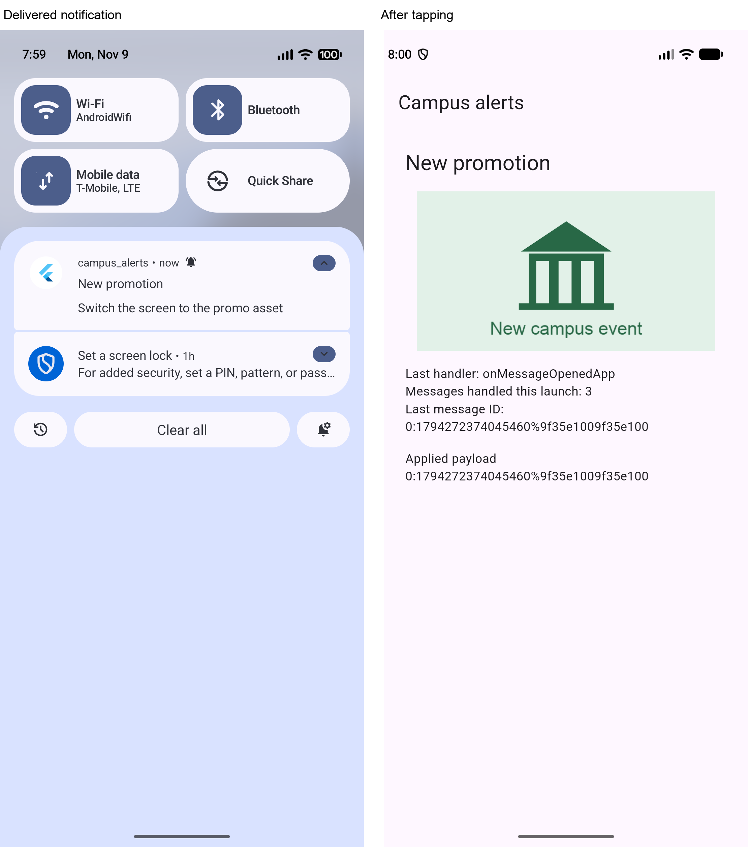

T3 Notification cold start
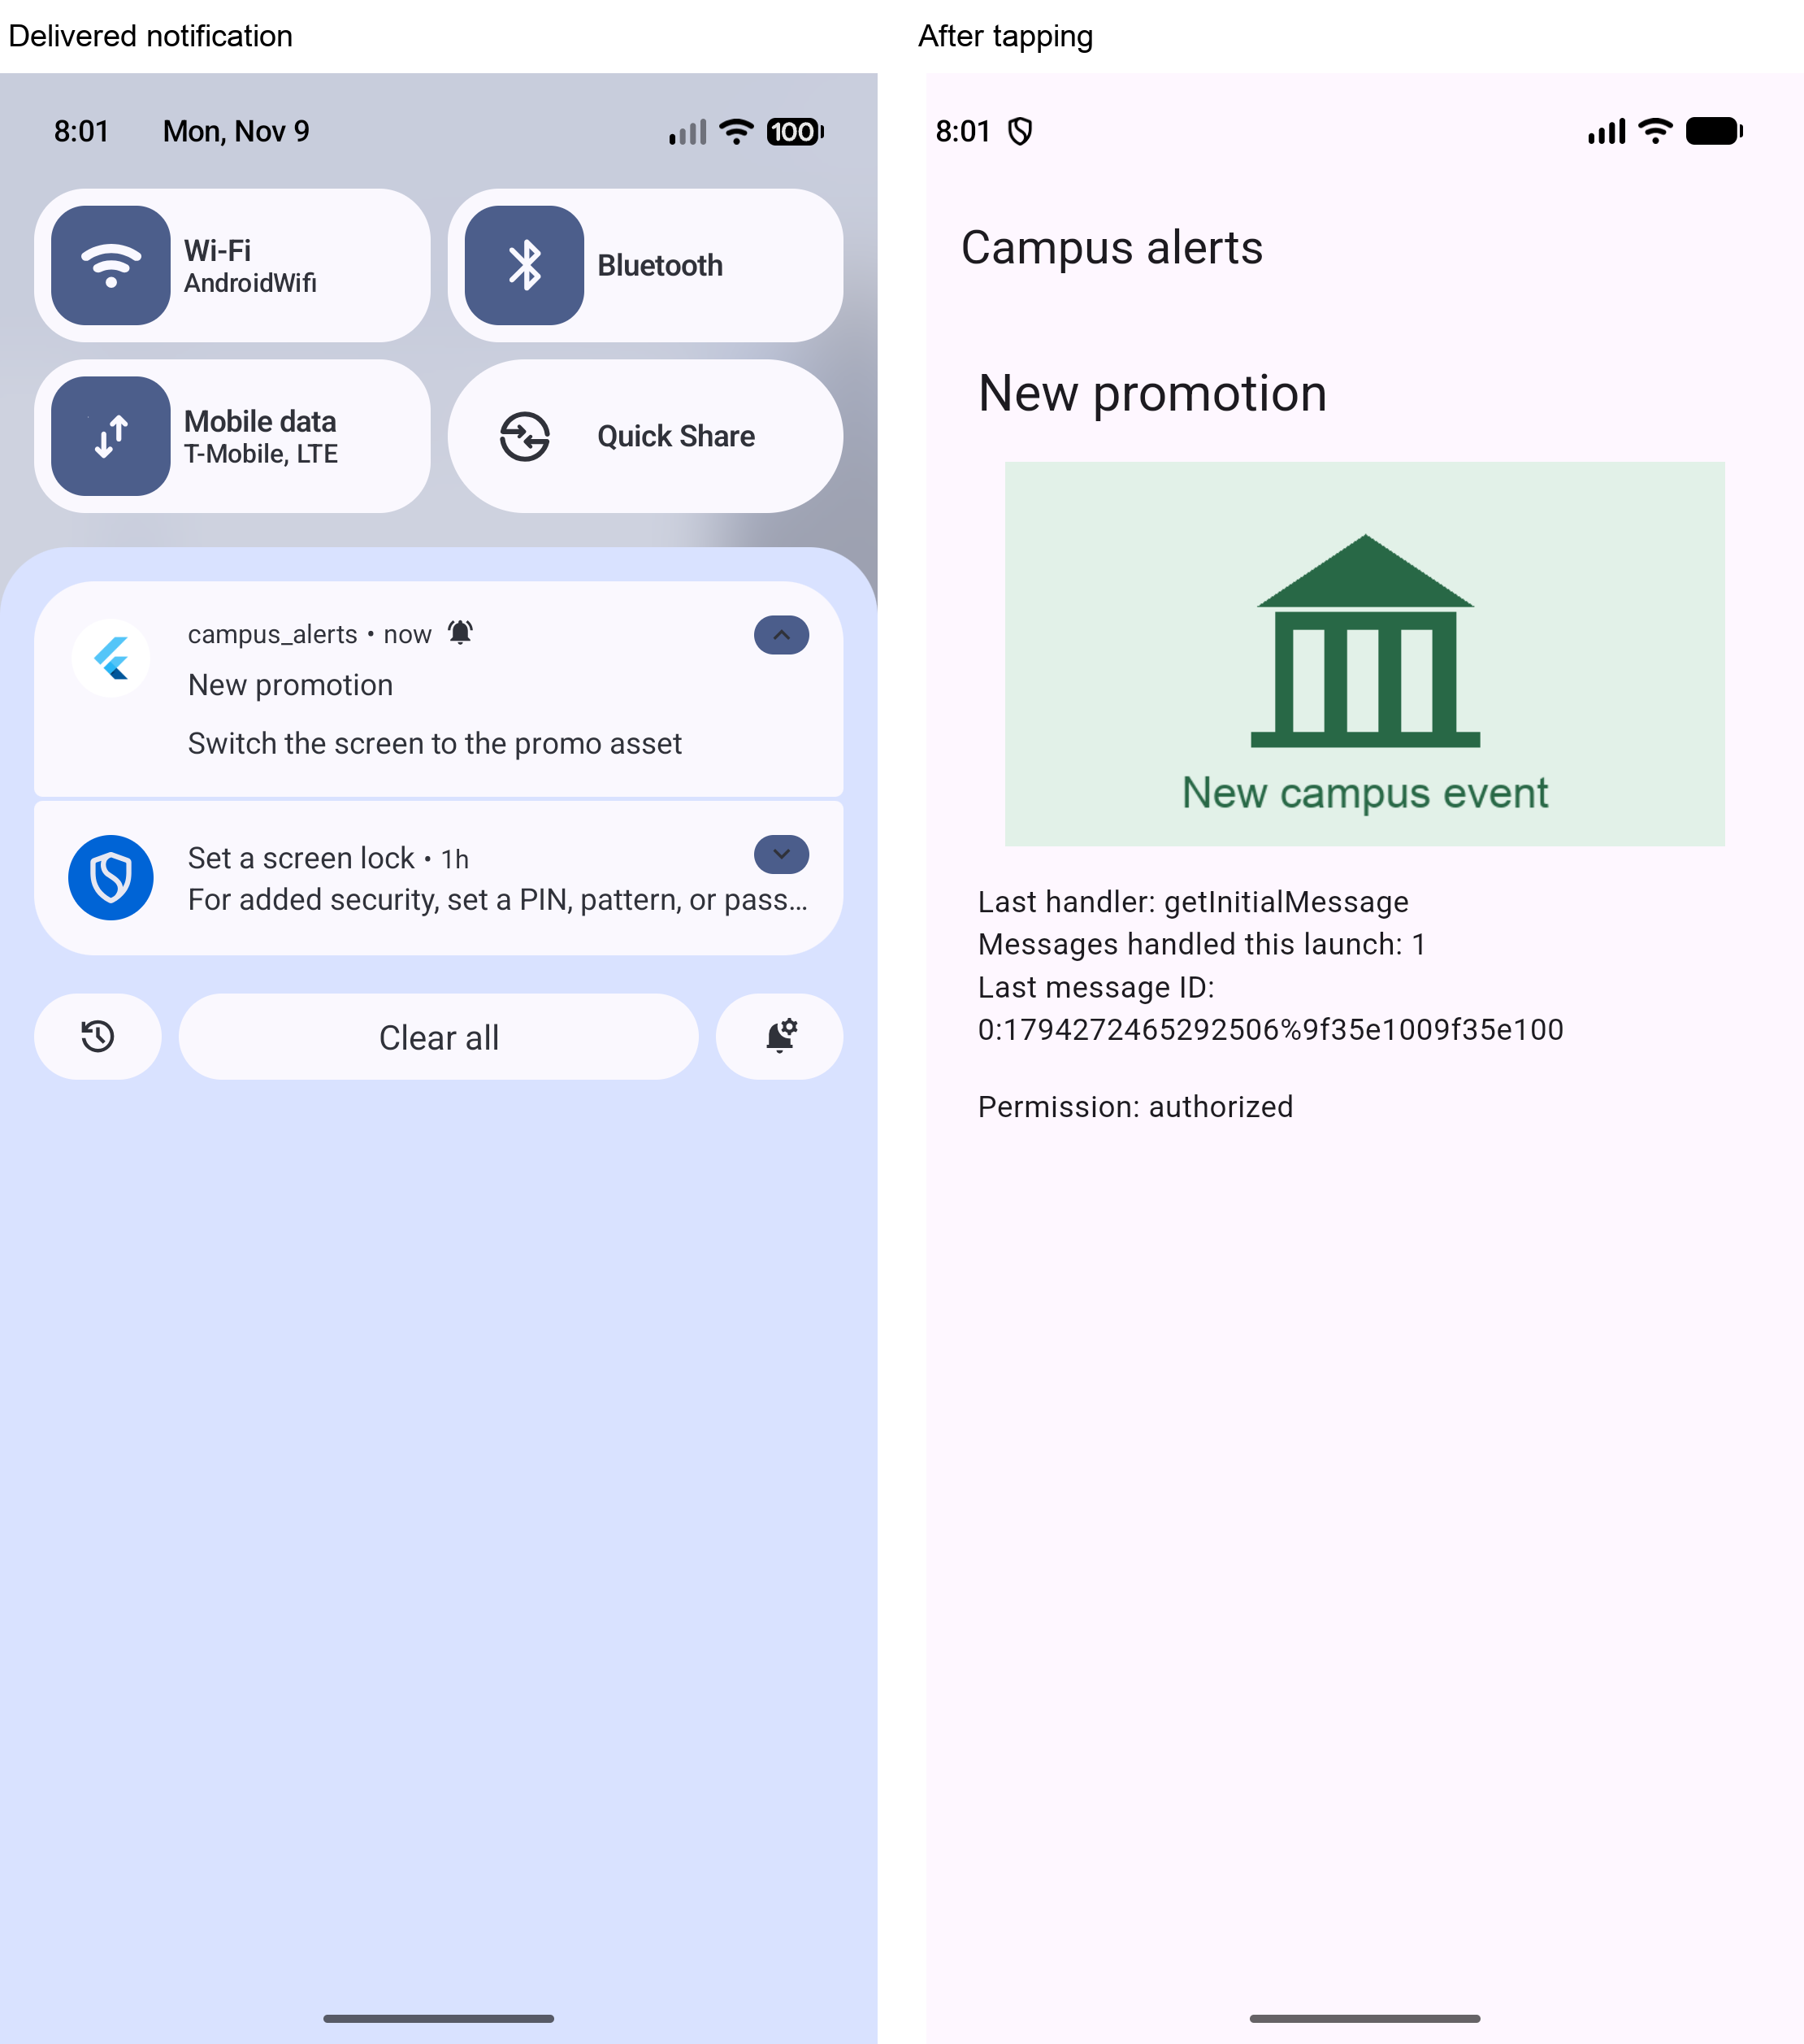

T4 Invalid payload


